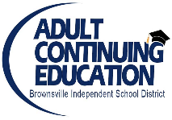 BISD Adult Continuing Education Consortium for Cameron County 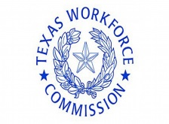
Dr. Jesus H. Chavez Ricardo Rivera
Interim Superintendent Director

WEEKLY LESSON PLANNER 2023-2024

TEACHER: ________________________________ DATE COVERED: _________________________________

CLASS SITE: ________________ Online Platform________________________ CLASS TYPE: ESL / HSE / MOS / GS5 (Circle class type(s))
 | MONDAY | TUESDAY | WEDNESDAY | THURSDAY | FRIDAY
OBJECTIVE
What do you want your students to learn from the lesson?
BENCHMARKS
COVERED
What TX Adult Ed. & Literacy Content Standard(s) will be addressed?
INTEGRATING CAREER AWARENESS
FINANCIAL LITERACY
https://edu.gcfglobal.org/en/topics/personal-finance/

Digital Literacy
Access
Security
Literacy

Family Literacy Objective
EL Civics
Essential Questions:

Lesson Objective:
Level Objectives | Lower Level : Students will be able to  Higher Level: Students will be able to |  | Lower Level : Students will be able to  Higher Level: Students will be able to
ACTIVITIES
(Warm-up, Introduction, Presentation, Pair work, etc.)
MATERIALS TO BE USED

EXPLANATION
How will concepts of procedures be described?
MODELING
If teaching concepts, what examples will be used? If teaching procedures, How will it be demonstrated?
GUIDED PRACTICE
How will learning be supported? What will students and teacher be doing?
APPLICATION
What will students be doing? How will success be monitored?
EVALUATION
How will you know if students have gained understanding of the
Concept?

