Dr. Jesus H. Chavez Ricardo Rivera
Interim Superintendent Director

BISD Adult Continuing Education Consortium for Cameron County

ATTENDANCE DOCUMENTATION
DUE DATES
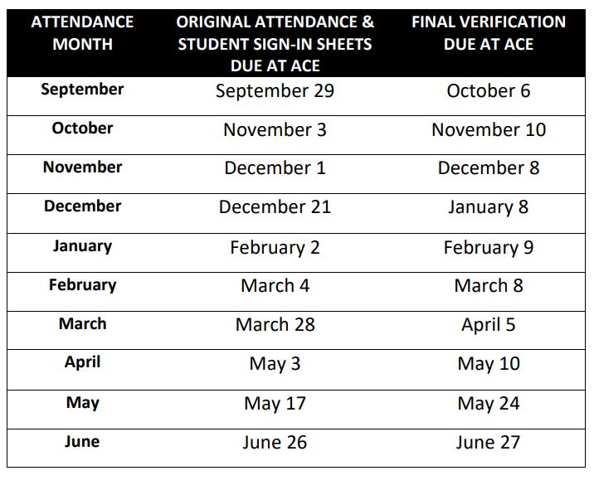
2023-2024

